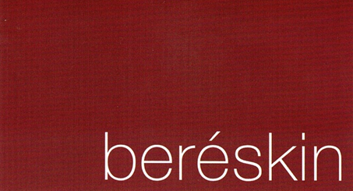
Calling All Photographers
Beréskin Gallery 2021
Photographic Exploration Project
PEP - Photographic Exploration Project
Show Dates: February 3rd to February 26th Opening: February 5th, 5:30 - 7:30 pm
Deadline for Submission: 1/2/2021 Notice of Acceptance: 1/4/2021
There is no theme for this open call. All styles and techniques are welcome. Let it be experimental, documentary, portrait, travel, cityscapes or any other approaches to photography (In accordance with PG rating. Suitable for all ages). This is an open call to Quad City area photographers of all ages and levels of experience. We look forward to discovering new visions of photography through the artist’s most personal approaches to image making as they capture what they are most passionate about. We want to feel the heart of the work!
Submit up to 2 entries per person. The participating artists will be selected through a jury of photographers and curators. A preview image of each item you propose to submit is required by January 2, 2021. The requirements for preview images: JPG format no larger than 900 pixels (long side). Each image should be saved with the title as:
Your Name_title of piece_location where photo was made_size of finished print_price (price to include 50% Gallery Commission) EXAMPLE:
PAT_SMITH_Snow_Tucson_AZ_16x20_$250 (Note: No empty spaces in image title)
Please upload preview image(s) on or before January 2, 2021 to:
http://www.dropbox.com/sh/v89w1yxuo3jorxn/AABsg0_3FgiPEKwvqJkCwvroa?dl=0
Framed (or otherwise finished, ready to hang) prints of accepted work are due by January 22nd, between 10 and 4 pm at the Beréskin Gallery located at 2967 State Street, Bettendorf, IA
Each finished piece must be clearly marked with photographer’s name, address, phone number, email, title of piece, size of finished print, location where photo was made, price (must include 50% gallery commission). Artwork must be ready to hang with appropriate framing and hangers - no duct tape.
For additional information contact Pat at the gallery, 2967 State Street, Bettendorf or bereskinartgallery@gmail.com. Riverbend Photo Video Club members may also contact Joe Maciejko (joeprimus42@gmail.com) with their questions.
To Register, submit your preview image(s) as directed above, then fill out and return this form, along with a $20 entry fee payment to Beréskin Gallery, 2967 State Street, Bettendorf, IA 52722 ($20 entry fee is waived for members of the Riverbend Photo Video Club)
Name _____________________________________________________________________________________
Address ___________________________________________________________________________________
Cell Phone ______________________________ Email _____________________________________________

